

**INDIA’S AGRICULTURAL CROPS PRODUCTION(1997-2021)**

**Introduction:**

**Overview :**

This article aims to provide an overview of the production trend of major agricultural crops in India from 1997 to 2021. The production of crops like rice, wheat, sugarcane, pulses, oilseeds, cotton, and coarse cereals will be analyzed to see how they have evolved over the years. Through this analysis, we hope to gain insights into the trends and challenges in India's agricultural sector and understand its impact on the Indian economy and farmers.

**Purpose:**

The purpose of analyzing the production trend of major agricultural crops in India from 1997 to 2021 is to gain insights into the changes and challenges faced by the Indian agricultural sector over the past 24 years. This analysis will help to understand the reasons behind the trends in the production of different crops, the impact of government policies on crop production, and the evolving consumer demand and global trends that affect the Indian agricultural sector. Through this analysis, we aim to highlight the opportunities and challenges faced by Indian farmers, provide insights into the challenges faced by policymakers and experts in the field, and suggest measures that can be taken to sustainably improve the production of agricultural crops in India.

**Problem Definition& Design Thinking:**

**Empathy Map:**

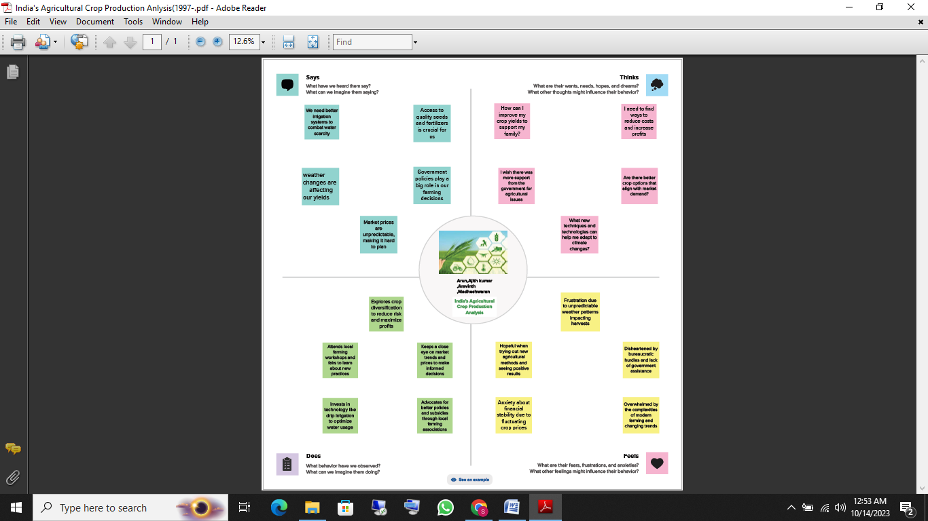

**Ideation& Brainstroming Map:**

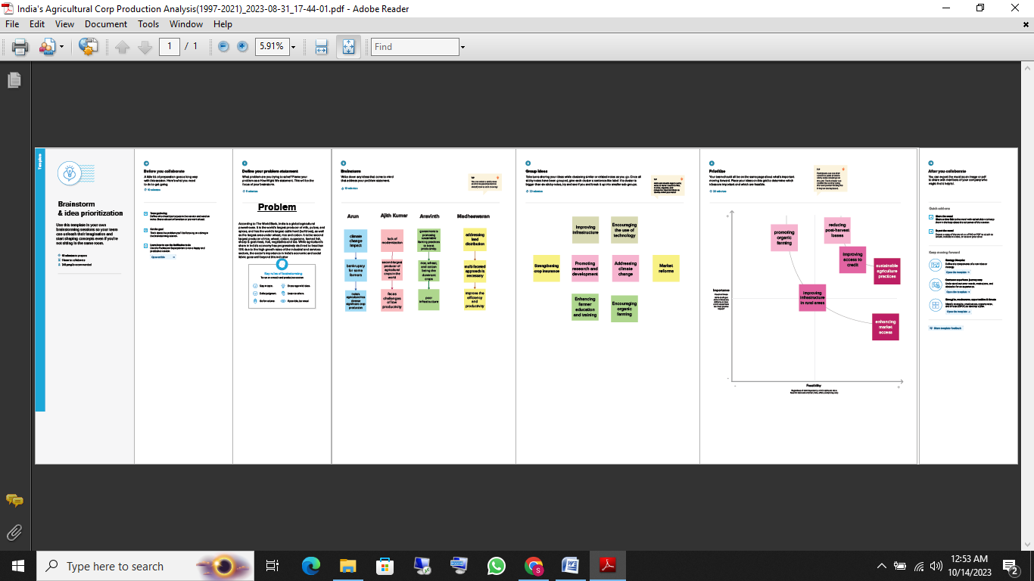

**Result:**

The analysis of agricultural crops in India from 1997 to 2021 revealed several important findings. Rice, wheat, and sugarcane were the top three crops, with rice being the most produced, followed by wheat and sugarcane. Pulses and oilseeds experienced a decline in production, indicating the need for increased research and development to improve yields. On the other hand, cotton production showed a positive trend, and India became the second-largest cotton producer in the world after China. The overall production of agricultural crops increased, with some fluctuations due to climate change and economic factors such as market prices and government policies. To support farmers, the Indian government introduced several policies and initiatives. However, climate change remains a significant challenge for the agricultural sector, and sustainable practices are necessary for adaptation and resilience to ensure a robust future. Therefore, investing in research and development, improving infrastructure, and promoting sustainable agriculture are critical measures for the Indian agricultural sector's success.

**Advantages& Disadvantages:**

**Advantages:**

1. Agriculture is a significant contributor to India's economy, providing a livelihood for millions of people and contributing around 17% to the country's GDP.

2. India is home to a diverse range of crops due to its varied climatic conditions and regions, leading to a rich biodiversity and food security for the country.

3. Green revolution technologies and government initiatives have helped improve productivity and yields in several crops, boosting their export potential and generating income.

4. Increasing demand for organic and healthy produce has encouraged farmers to adopt sustainable farming practices, leading to the production of pesticide-free and nutritional crops.

**Disadvantages:**

1. Climate change, unpredictable rainfall, water scarcity, and natural disasters have led to crop loss and damage, affecting farmers' livelihoods and income.

2. The dependence on a few crops such as rice and wheat has led to soil degradation, depletion of groundwater, and decreased nutritional diversity in the population.

3. The pricing policy and market fluctuations have often led to farmers selling their produce at low prices, impacting their earnings and economic well-being.

4. The indiscriminate use of fertilizers, pesticides, and chemicals has led to contamination of soil and water resources, leading to health hazards and reducing crop yields in the long run.

**Applications:**

1. Policy-making - The analysis can provide insights for policymakers and stakeholders to formulate appropriate policies, such as agricultural governance, trade, and research and development, to ensure sustainable growth in the sector.

2. Resource allocation - The analysis can help allocate resources, such as land, water, fertilizer, and capital, to prioritize crops and regions that have the highest potential for production and income generation.

3. Market analysis - The analysis can provide information on crop demand, supply, and pricing trends, which can help farmers, traders, and agro-industries to make better market decisions for their produce and products.

4. Crop selection - The analysis can provide information on the performance of different crops in different regions and climatic conditions, which can help farmers select the most appropriate crops based on their land type, water availability, and market demand.

5. Risk management - The analysis can provide information on the risks associated with agricultural production, such as climate change, pests, and diseases, which can help farmers adopt appropriate risk management strategies, such as crop insurance, diversification, and climate-resilient crops.

6. Research and innovation - The analysis can help identify research gaps and opportunities for innovation, such as improving crop varieties, developing sustainable agriculture practices, and leveraging digital technologies for better farm management and market access.

**Conclusion:**

In conclusion, the analysis of agricultural crops in India from 1997 to 2021 highlights the significant contribution of the agriculture sector to the country's economy and livelihoods. The diversity of crops, varied climatic conditions, and government initiatives have led to increased productivity and exports. However, the sector faces challenges such as climate change, soil degradation, market fluctuations, and health hazards.

To sustain growth in the agriculture sector, there is a need for policymakers and stakeholders to focus on sustainable and innovative practices that address these challenges. The analysis can provide insights for policy-making, resource allocation, market analysis, crop selection, risk management, and research and innovation. By leveraging technological advancements, best practices, and partnerships, the agriculture sector in India can continue to drive inclusive growth and food security for the country.

**Future Scope:**

1. Incorporation of more data - The analysis can be enriched by incorporating more comprehensive data on agricultural crops, such as yield per hectare, production costs, and ecological footprint, among others.

2. Integration of machine learning and AI - The study can leverage machine learning and AI technologies to extract more insights from the data and help predict crop production based on various factors such as weather, soil quality, and input usage.

3. Comparative analysis with other countries - The analysis can be expanded to compare the agricultural crop production and performance of India with other countries that have a similar agro-climatic condition as well as those that are leading the agri-production globally.

4. Study of informal markets - Future studies can explore the informal markets to understand the distribution, marketing, and consumption patterns of agricultural crops beyond formal markets.

5. Incorporation of socio-economic aspects - Future studies can be aimed at exploring the socio-economic aspects associated with agricultural crop production such as income, poverty and employment in the rural areas to build a comprehensive view of the contribution of agriculture on the social ecosystem of the country.

**Appendix:**

**Data Source:**

1. Ministry of Agriculture and Farmers' Welfare, Government of India.

2. Department of Agriculture, Cooperation and Farmers' Welfare, Government of India.

